PLEASE FOLLOW THESE INSTRUCTIONS VERY CAREFULY – 5 minute read

This program will create a zip file that you can download. This Zip file will be emailed to you.

The program will create a CSV file that you can upload to the conjoint website.

HOW DOES THIS WORK?

This tool works by analysing data found within the PDF files of the colonoscopy reports then using a Private AI tool (on a private server) it will analyse the data within the PDF reports and fill out the conjoint colonoscopy logbook CSV file. This “CSV” file can be uploaded to the website as a method to bulk upload a larger number of reports.

This works best with PDF files which are found within the folder of your colonoscopy software (especially Olympus software). It also works for colonoscopy reports that have been scanned (as a PDF file). However for scanned reports the success of this software is determined by how well the report is scanned. Poor quality scans are unlikely to be used accurately.

ARE MY REPORTS SECURE?

No Patient data is sent to external providers. All data is encrypted. The email that is sent to you with a copy of the analysed files is not accessible by me or my website.

HOW ACCURATE IS THIS TOOL

This tool is greater than 99% accurate. Where it is been found to be inaccurate is in its guess of a patient’s gender. As nearly all colonoscopy reports do not provide information about the patient’s gender. The tool uses the AI to guess the patients gender. Patients with non-Caucasian names may have their gender mischaracterised slightly more frequently than others. Some names are unisex and therefore hard to know if they are male or female.

When a report is very ambiguous about its description of the number of polyps removed this also may result in an inaccurate calculation of the number of polyps removed.

WHAT IF I GET AUDITED?

This tool provides you with text files for every colonoscopy report. If you do get audited you will have all of the files ready for upload.

To reduce the probability of being audited we routinely fill the box called “other comments” with the last 300 characters of the colonoscopy report. This section usually contains the conclusion of the report.

For those who currently use the histology tool on this website, the Pathology box is also filled in to limit the probability of an audit (note as of 15-6-25 this tool is in BETA).

TWO FACTS TO BE AWARE OF:

- BEWARE. The CSV upload tool to the conjoint website is VERY FINCKY – ANY ERRORS in formatting and the file wont upload
- Commonest errors
  - 1) By simply opening a csv (file) on a mac (or on some windows computers) wont realise that the dates in the csv file will be auto formatted and zeros (“0”) will be removed. The conjoint website only accepts dates in the format 01/01/2025 but if the date is autoformatted to 1/1/2025 then it will reject the whole file. In order to avoid this DO NOT OPEN THE CSV FILE IN THE FOLDER CALLED “DO NOT OPEN FILES IN HERE”. If you accidently do this see below
  - People accidently upload and analyse colonoscopy reports conducted In the prior conjoint period. For example if you last conducted your conjoint recertification in October 2024 and uploaded reports for AI analysis on this website before October 2024 (for example September 2024). They will be analysed and added to the CSV but when the CSV is uploaded to the conjoint site it will reject the file.

WHAT IF I OPEN MY CSV AND THE DATE IS EDITED?

If this occurs on a MAC then open the file with the program “Numbers”

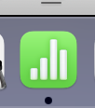

After you open the file, highlight the column with the dates (see example below):
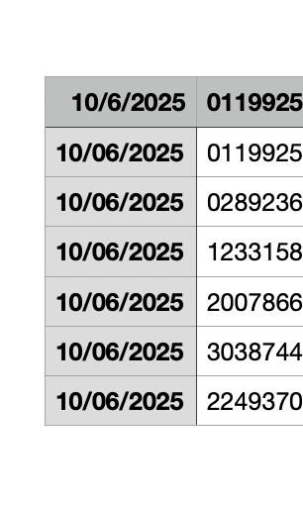
Then on the right hand side where it says table/cell press the “cell” button. Here is an example:

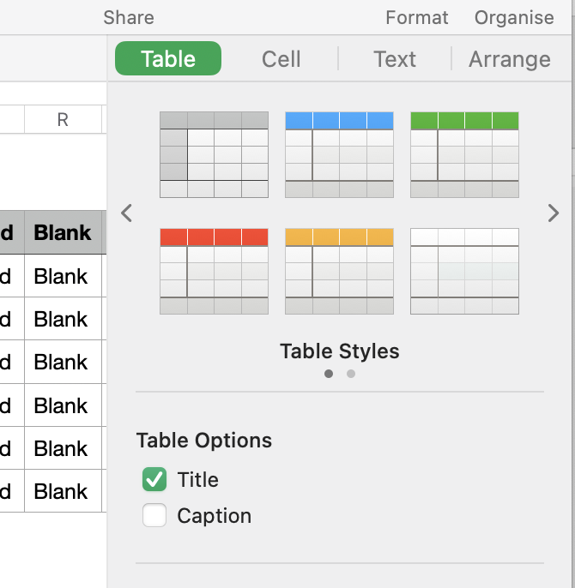

Once you press Cell it will say Date Format = Automatic

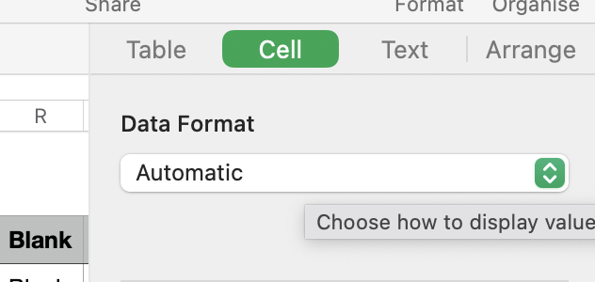

Change this to “Text”

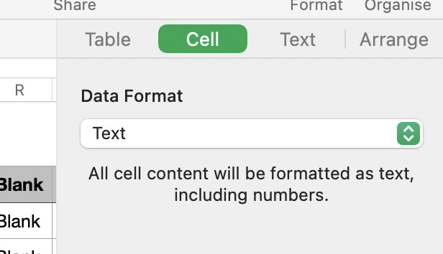

Then select the date that is incorrect and change it. See example below.

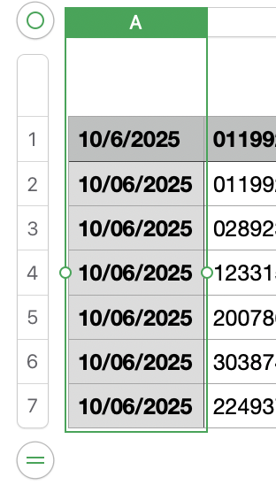

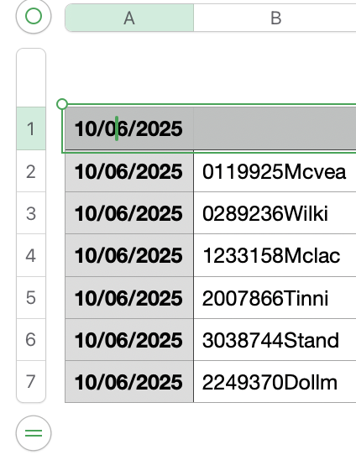

Once you have made your changes press “file”

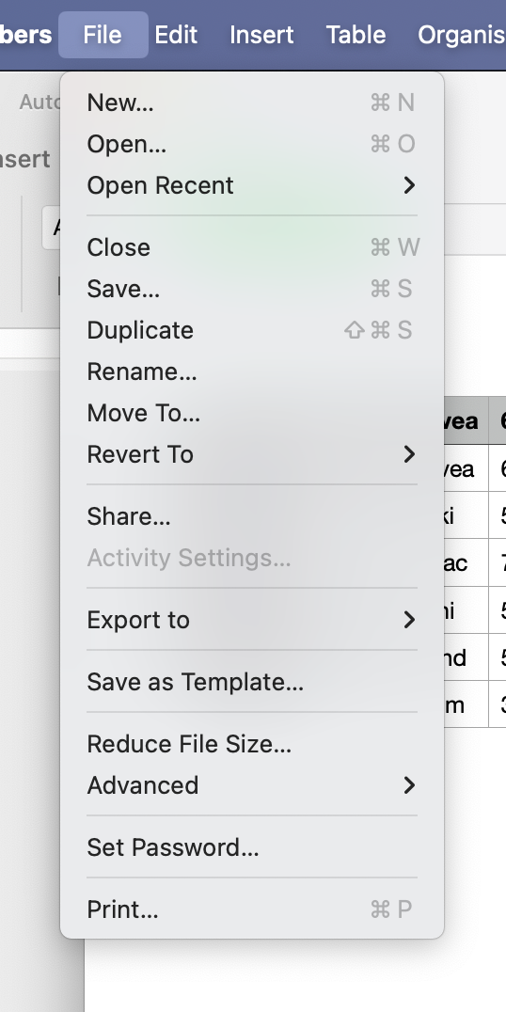

Then press “Export to” and chose CSV

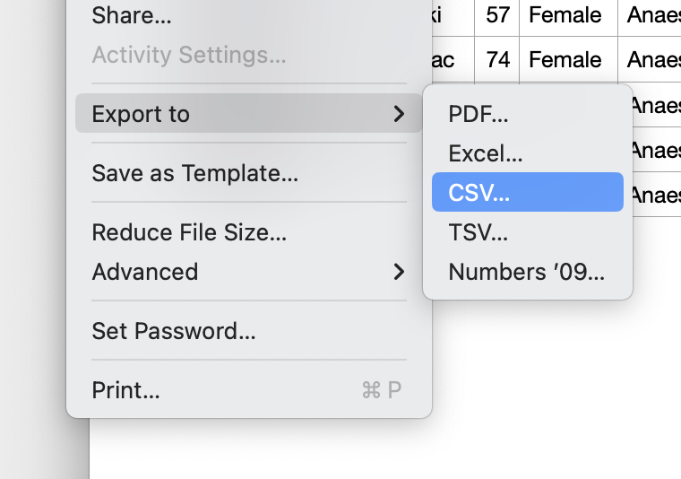

Your file should be accepted by the website (assuming you didn’t change it in another way)

HISTOLOGY

You must decide whether you upload your histology for AI analysis separately with the included tool OR manually add histology

Manual addition. – CURRENTLY MOST ACCURATE

Once you have uploaded the CSV to the conjoint website all of your reports will have 0 next to adenoma and SSA. (See below the first patient where it says Polyps 2, Adenoma 0 and SSA 0)

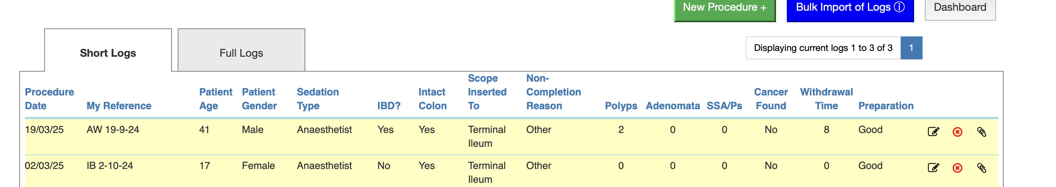

You then click the edit tool next to the relevant file

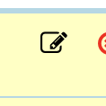

Which opens the patient in question:

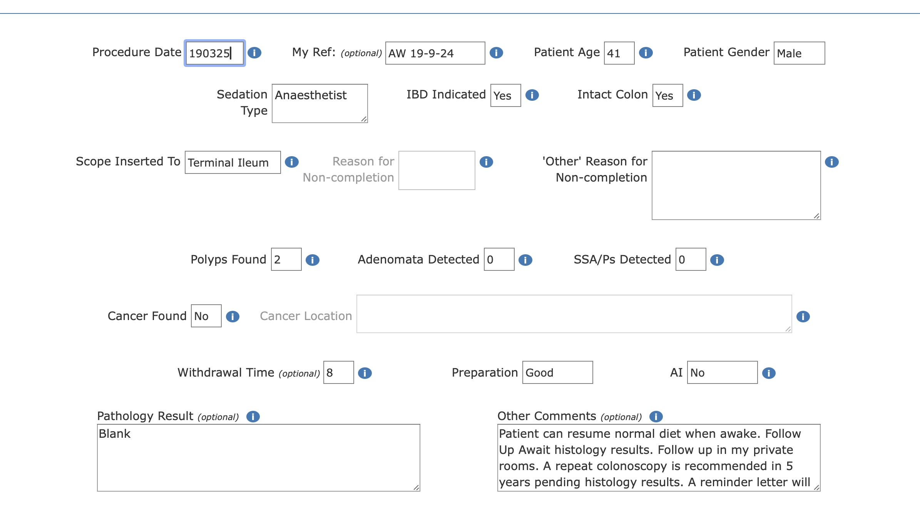

You may then review the histology (using records, private practice software etc) and change the “Adenoma detected” or “SSA/Ps Detected” to whatever number is relevant to the patient.

Repeat this for all of the patients who have polyps.

The list of patients who require histology are found in the WORD DOCUMENT provided to you in the Zip file (Called analysis report.docx).

See below as an example that is provided in the document:

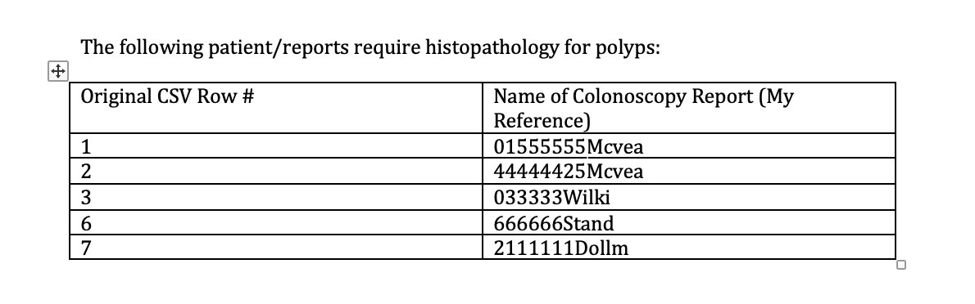

AI HISTOLOGY TOOL

This tool is in BETA as of 15-6-25

All histology files need to be in PDF or TXT format.

Each file should be a separate patient, Do not merge multiple patient data within the same file.

In the original ZIP file provided t you post colonoscopy PDF analysis, there is a folder called “histology csv”. Upload the “Pathology.csv” file into the histology upload link.

Upload the histology files into the histology files link.

You will then be provided with a ZIP file with the CSV file for upload to the conjoint website. You will also be provided with audit files if you are audited.

